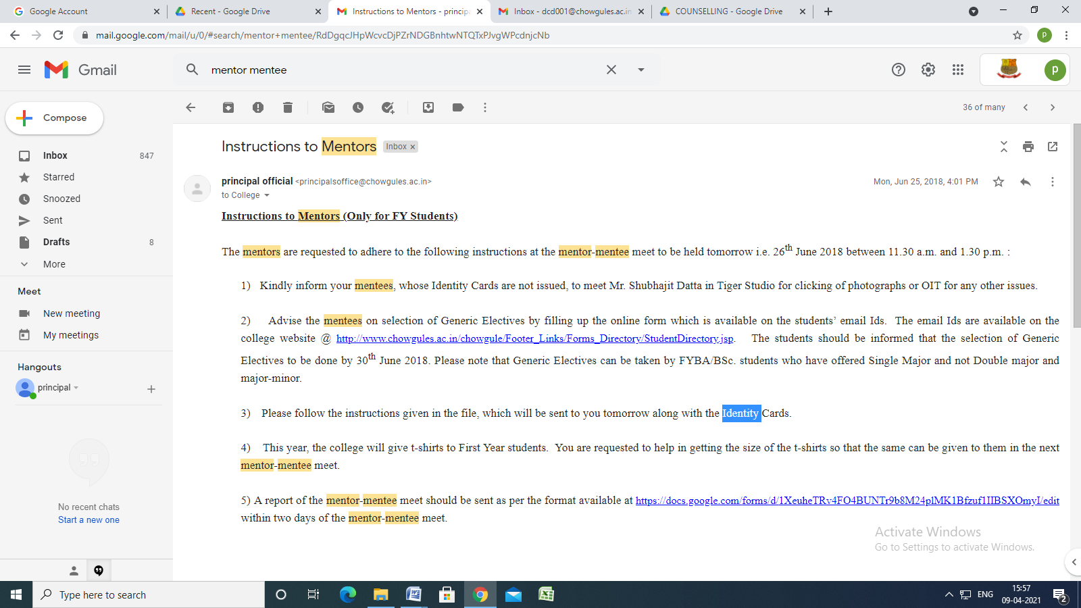

Instructions to Mentors
Inbox
principal official <principalsoffice@chowgules.ac.in> | Mon, Jun 25, 2018, 4:01 PM
to College

Instructions to Mentors (Only for FY Students)

The mentors are requested to adhere to the following instructions at the mentor-mentee meet to be held tomorrow i.e. 26th June 2018 between 11.30 a.m. and 1.30 p.m. :

1) Kindly inform your mentees, whose Identity Cards are not issued, to meet Mr. Shubhajit Datta in Tiger Studio for clicking of photographs or OIT for any other issues.

2) Advise the mentees on selection of Generic Electives by filling up the online form which is available on the students’ email Ids. The email Ids are available on the college website @ http://www.chowgules.ac.in/chowgule/Footer_Links/Forms_Directory/StudentDirectory.jsp. The students should be informed that the selection of Generic Electives to be done by 30th June 2018. Please note that Generic Electives can be taken by FYBA/BSc. students who have offered Single Major and not Double major and major-minor.

3) Please follow the instructions given in the file, which will be sent to you tomorrow along with the Identity Cards.

4) This year, the college will give t-shirts to First Year students. You are requested to help in getting the size of the t-shirts so that the same can be given to them in the next mentor-mentee meet.

5) A report of the mentor-mentee meet should be sent as per the format available at https://docs.google.com/forms/d/1XeuheTRv4FO4BUNTr9b8M24plMK1Bfzuf1IIBSXOmyI/edit within two days of the mentor-mentee meet.

Dr. Nandkumar N Sawant
Principal

